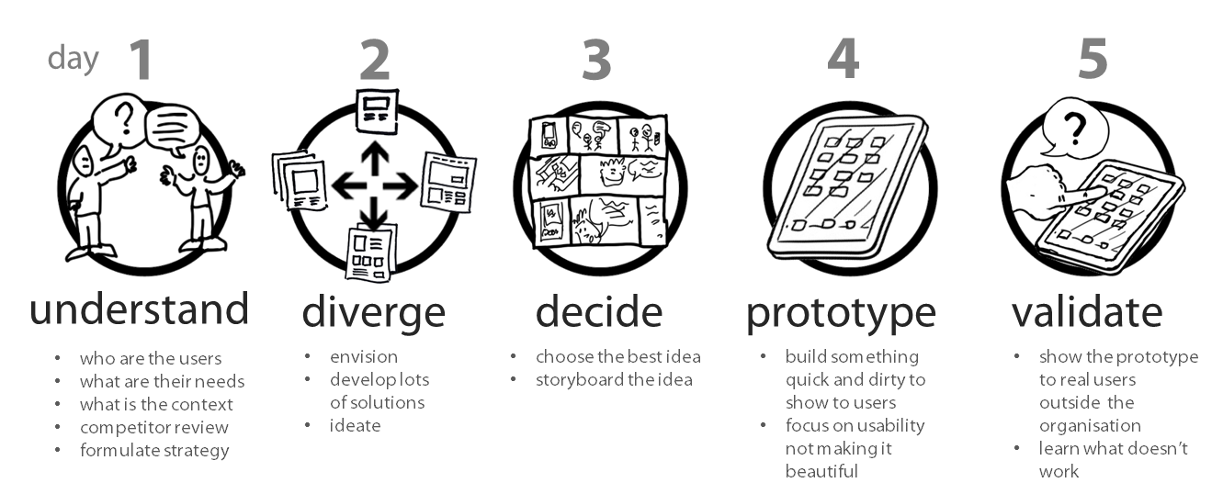

# UNDERSTAND AND DIVERGE:

**Who, What, How, Why (Comprehend Situation)**

* WHO (Identify Customer)
  + 1
  + 2
  + 3
* WHAT (Offering)
  + 1
  + 2
  + 3
* HOW (List Solutions)
  + 1
  + 2
  + 3
* WHY
  + 1
  + 2
  + 3

# DECIDE

**Positioning Statement (Report Customer Needs)**

For [your audience], [your brand] is the [your market] that best delivers on [your brand promise] because [your brand], and only [your brand], is [your evidence].

**Example:**For the young and young-at-heart, Walt Disney World is the theme park that best delivers on an immersive and magical experience because Walt Disney World, and only Walt Disney World, connects you to the characters and worlds you most desire. (**Tagline:**“Where Dreams Come True”.)

1. **Your audience**: Who is your demographic? What are their pain points?
2. **Your market**: What is your market category? And, how does your brand better relate to your audience, in comparison to your competition?
3. **Your brand promise**: Think back to your audience’s pain points and then ask yourself, how does your brand solve those problems? **In the eyes of your audience**, what are the greatest benefits your brand offers?
4. **Your evidence**: What irrefutable evidence can you offer to demonstrate that your brand delivers on its promise?

# PROTOTYPE

**User Journey**

Other features?

**MVP Feature Set**